CHELCIE JETTE
SOPRANO · VOCAL RANGE D3–E6
chelciegette@gmail.com | www.chelciejette.com | 814-450-7804
Professional vocalist with a three-octave range (D3–E6) and a decade of professional vocal work across live performance, studio sessions, and an original album release. Vocal powerhouse type with credits in voice-driven roles — Mary Magdalene, Eva, Fastrada — paired with extensive improv and Meisner training for comedic and character versatility.
EDUCATION
Berklee College of Music — Bachelor of Music, Vocal PerformanceBoston, MA
MUSICAL THEATER
NASHVILLE, TN (2024–PRESENT)
Gussie u/s & Ensemble | Merrily We Roll Along | HPAC Theater (2026)
Mary Magdalene | Jesus Christ Superstar | New Star Nashville
Polly | Sayre (original production) | BSN Theatre
Fastrada | Pippin | Murfreesboro CTFA
Eva u/s & Ensemble | Evita | The Keeton Theatre
ERIE, PA (2013–2015)
Ms. Sandra | All Shook Up | Erie Playhouse
Chris | Carrie: The Musical | Erie Playhouse
Patty Simcox | Grease | Erie Playhouse
PROFESSIONAL VOCAL WORK
Lead Vocalist — The Jordan Kahn Orchestra (Dallas, TX) — 4–6 live gigs monthly; featured in full-band shows and regular solo piano/vocal performances (2016–Present)
Recording Artist — MAKE WAY — original 6-song album, available on all major streaming platforms (2022)
Studio & Demo Work — Demo vocalist for Nashville producer Josh Rosen; backing vocalist for The Mad Sugars (2019–Present)
TRAINING
Voice — 15 years of study — Linda Balirro, Maureen Murphy, Liz Johnson, Angela Fels
Improv & Comedy — Third Coast Comedy — Improv Levels 1–6; performing troupe member (2026)
Acting — Meisner Technique — The Actors Bridge Studio, Nashville
Dance — Musical Theater Dance — Nashville
SPECIAL SKILLS
Piano · Sight-reading · Harmonizing & ear singing · Improv comedy · Studio recording experience · Moves well
CHELCIE JETTE
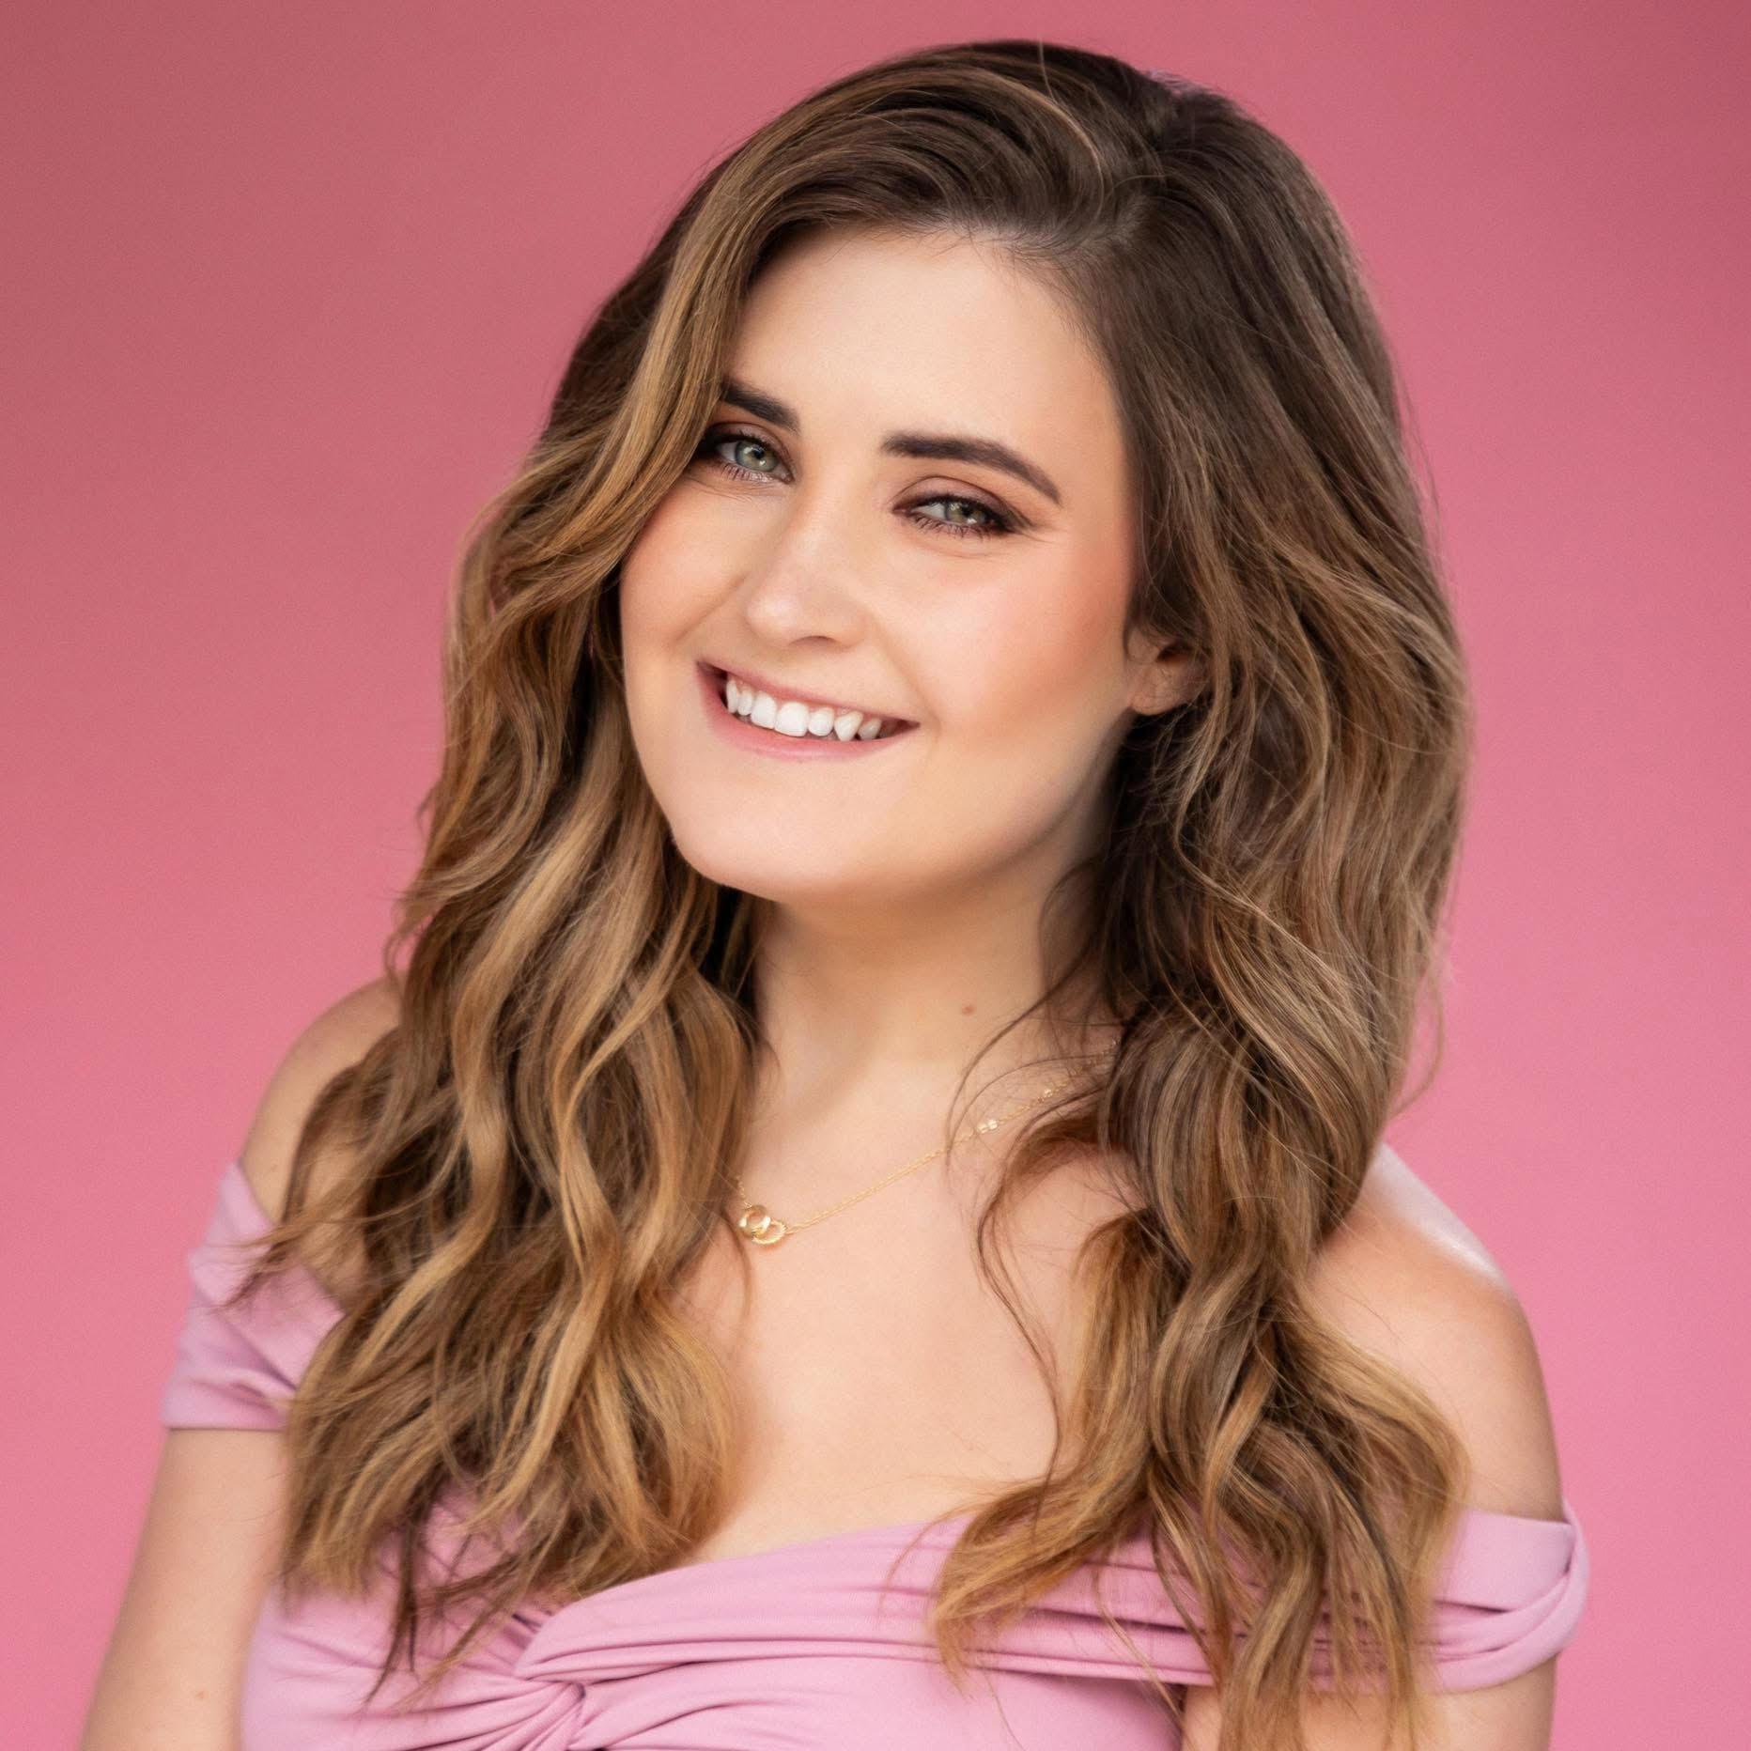
SOPRANO · D3–E6 · www.chelciejette.com

